**SVKM'S NMIM’S Nilkamal School of Mathematics, Applied Statistics & Analytics**

**Master of Science (Data Science)**

Practical-4 Storage as a service using AWS.

**Writeup:-**

* **Storage as a service-s3**

**Amazon Simple Storage Service (Amazon S3) is an object storage service that offers industry-leading scalability, data availability, security, and performance. Customers of all sizes and industries can use Amazon S3 to store and protect any amount of data for a range of use cases, such as data lakes, websites, mobile applications, backup and restore, archive, enterprise applications, IoT devices, and big data analytics. Amazon S3 provides management features so that you can optimize, organize, and configure access to your data to meet your specific business, organizational, and compliance requirements.**

**Amazon Simple Storage Service (Amazon S3) is an object storage service offering industry-leading scalability, data availability, security, and performance. Customers of all sizes and industries can store and protect any amount of data for virtually any use case, such as data lakes, cloud-native applications, and mobile apps. With cost-effective storage classes and easy-to-use management features, you can optimize costs, organize data, and configure fine-tuned access controls to meet specific business, organizational, and compliance requirements.**

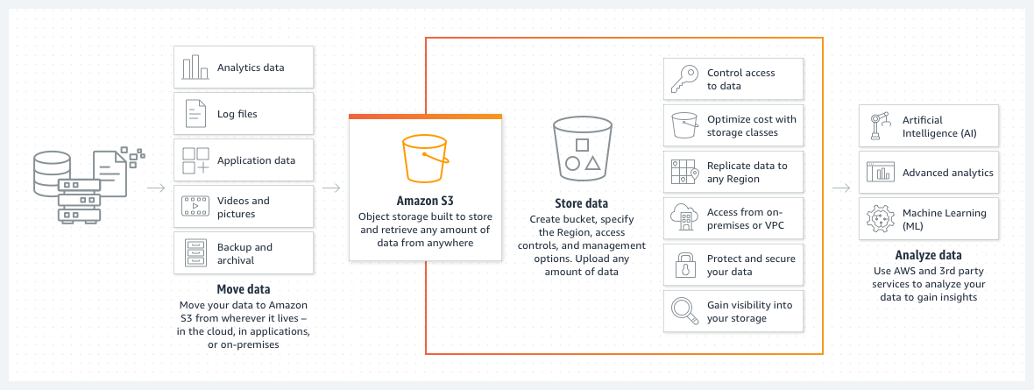

* **S3 use cases**

### Build a data lake Run big data analytics, artificial intelligence (AI), machine learning (ML), and high performance computing (HPC) applications to unlock data insights.

### Back up and restore critical data

Meet Recovery Time Objectives (RTO), Recovery Point Objectives (RPO), and compliance requirements with S3’s robust replication features.

### Archive data at the lowest cost

Move data archives to the Amazon S3 Glacier storage classes to lower costs, eliminate operational complexities, and gain new insights.

### Run cloud-native applications

Build fast, powerful mobile and web-based cloud-native apps that scale automatically in a highly available configuration

* **Steps for s3**
* **Sign in to the AWS Management Console and open the Amazon S3 console at** [**https://console.aws.amazon.com/s3/**](https://console.aws.amazon.com/s3/)**.**
* **Create a bucket**
* **Add an object to Bucket**
* **Add a folder to Bucket**
* **View an Object**
* **Move an Object**
* **Delete an Object and Bucket**
* **To empty a bucket**
* **To delete a bucket**
* **Hosting a Static Website on Amazon S3**
* **AWS user to control S3**

**Implement S3 for :**

1. **uploading a file,video,etc.**

**Step 1:- Sigin to AWS -> search for S3 services**

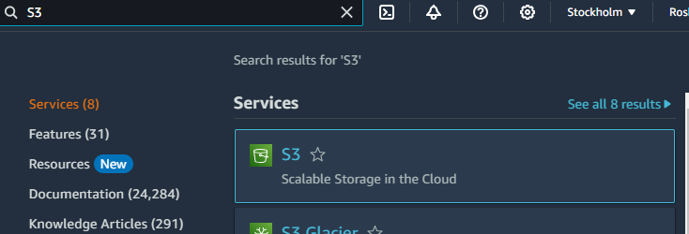

**Step 2:- Create a bucket -> Select AWS Region -> Provide a Bucket name ->Keep the further settings as default -> then select create bucket option**

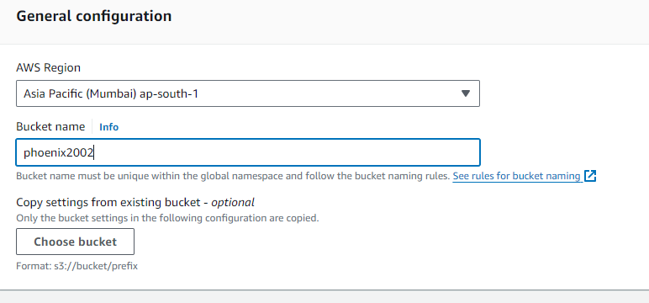

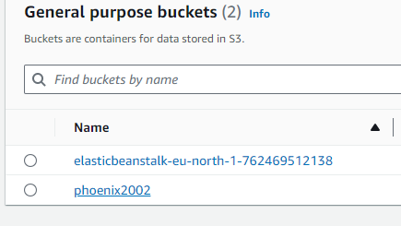

**Step 3- Upload any file(image videos etc) -> Add files**

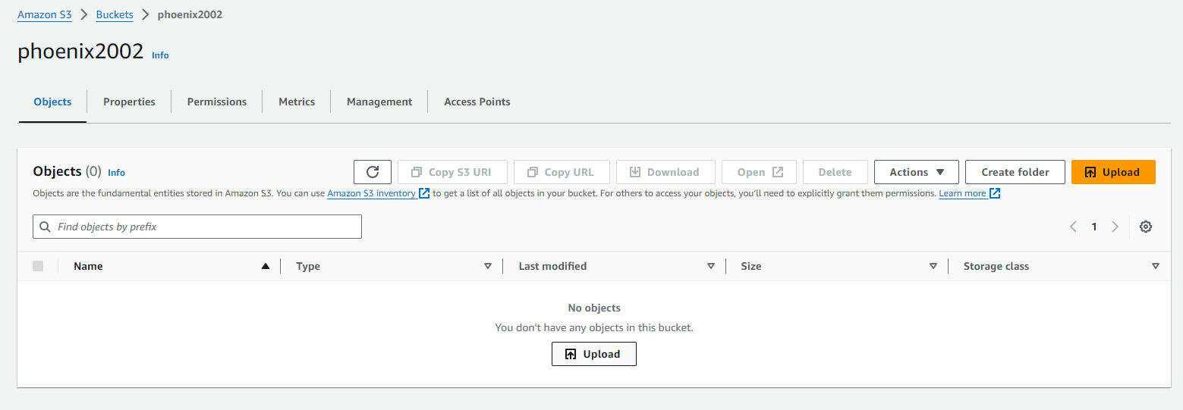

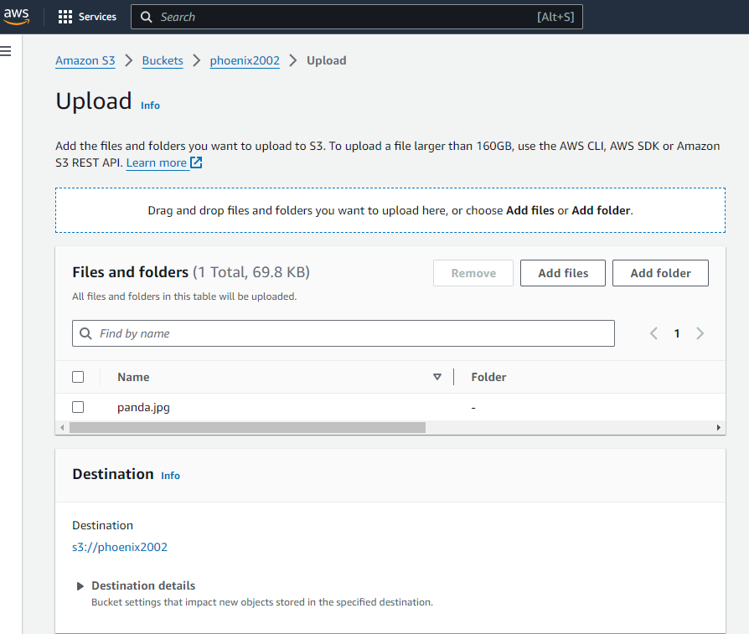

**Step 4:- Select the file and click on Upload**

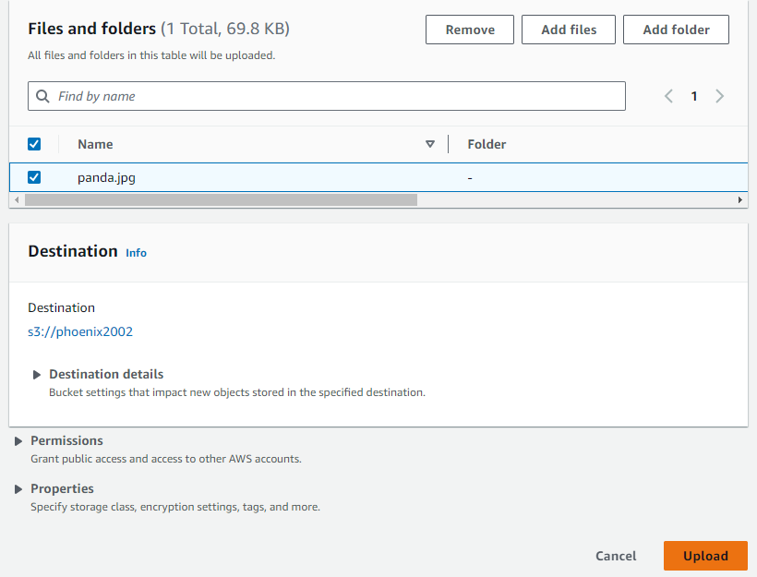

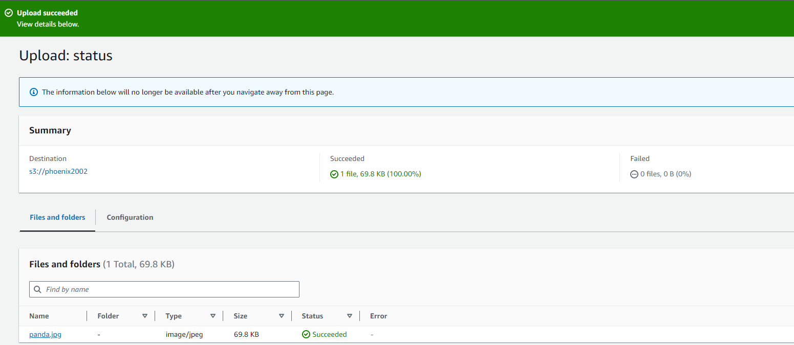

**Step 5:- Click on Open**

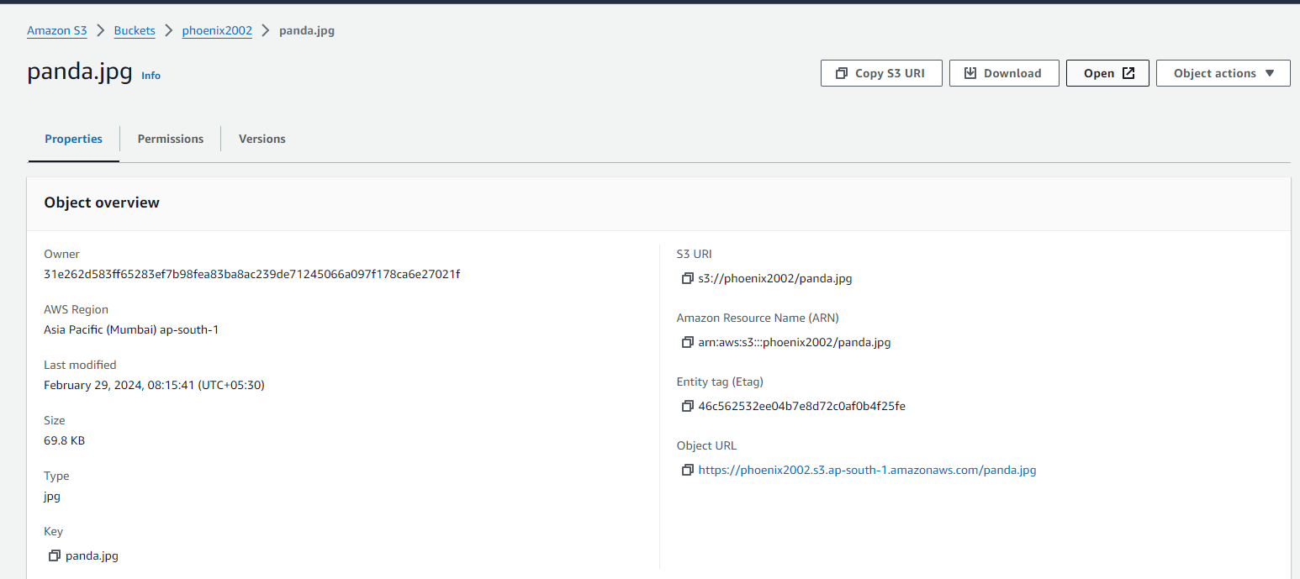

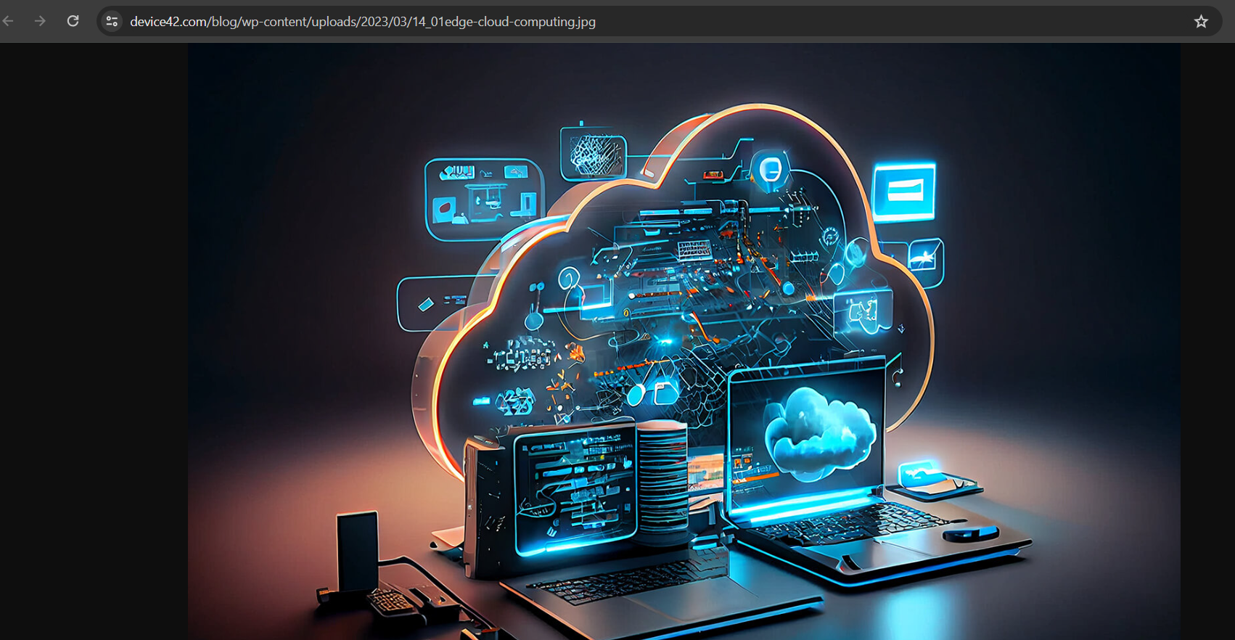

1. **uploading a static website**

**Follow the same steps till Step 2 and upload any static file -> click on the link**

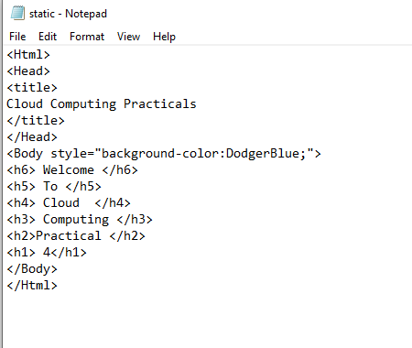

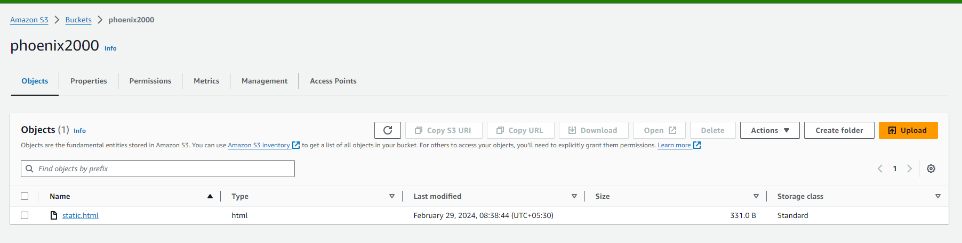

**Follow step 5 given above**

